**Inspection of the Structure:**

We inspected the Agricultural Bank on 4/4/2024 to assess the structural damage. This was carried out in three main stages:

1. Preliminary Inspection

2. Actual Inspection

3. Structural Assessment and Proposal of Technological Solutions for Damaged Components

**First Stage:**

We faced difficulties obtaining architectural drawings; only an initial ground-floor plan was available. As a result, we had to take measurements for each floor separately and draft preliminary sketches to later transfer them to Revit.

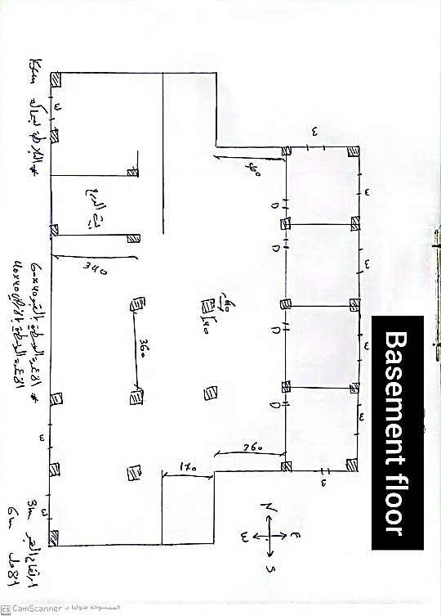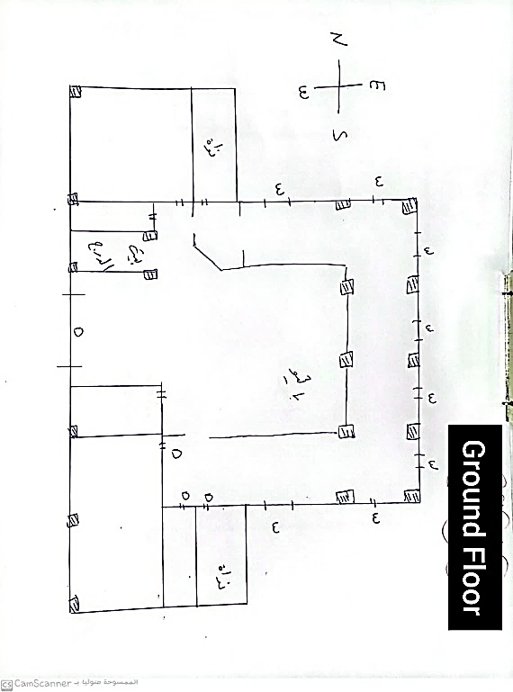The following figure illustrates:

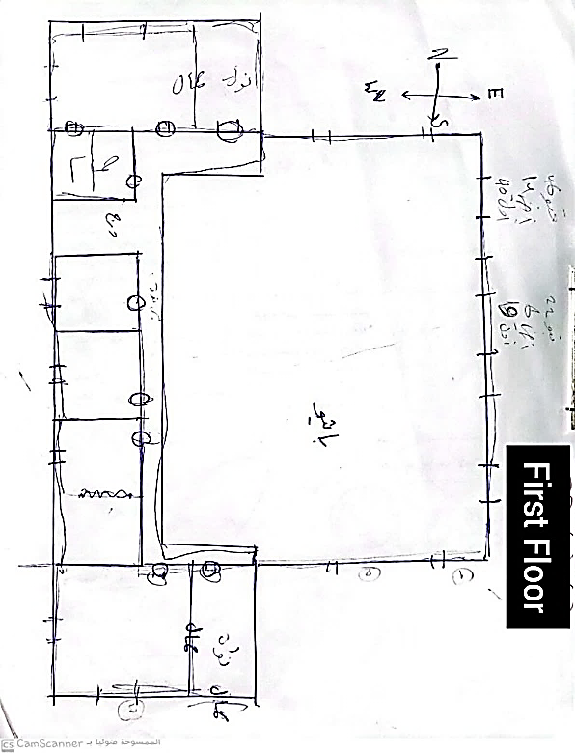*Preliminary sketch of floor plans prepared before evaluating the condition.*

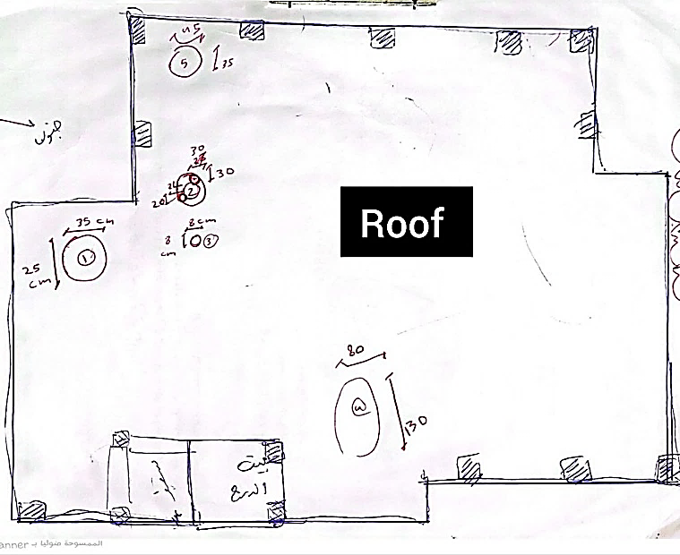

***Inspection Phases:***

1. General Preliminary Examination of the Building

**This included external and internal inspection, as follows:**

**- External Building Inspection (Main Facades):**

1. Observed no vertical or horizontal inclinations in the concrete structure across its height ✔

2. Noted the absence of buckling or cantilevered slabs ✖

3. Observed water leakage from sanitary fixture joints across various floors ✖

4. Observed ground water seepage beneath exterior walls ✖

5. Noted cracks in exterior walls, especially near window corners and lintels ✔

**-Internal Building Inspection:**

1. Tested ease of opening and closing doors and windows to ensure there are no deflections in the upper roof beams. ✔

2. Observed water seepage in bathrooms as well as on the ground floor or basement floor. ✖

3. Noted swelling in ceiling slabs. ✖

4. Observed concrete cover collapse on columns, beams, and slabs, and rust on exposed reinforcement steel. ✔

5. Checked the condition of floor tiles on the ground floor or basement for settlement or unevenness (no settlement was observed).

At this stage, we filled in Annex No. 1 (Forms for Inspecting Damaged Buildings 4, 5, 6) approved by the Syrian Engineers Syndicate. These forms helped us better understand the building, gain an overall view of the structure, and identify the most affected areas and components. This allowed for more effective management of the inspection process and a more accurate engineering assessment.

|  |
| --- |
| **The Syrian Arab Republic The Syrian Engineers Syndicate**  Building Inspection Form |
| The Engineer: Batoul Alsaadi & Alaa Barazi The Sector: Construction |
| **Building Location**  The Number: The Street: The Neighborhood: The City: Souran |
| Construction Date: 1995 |
| Special Information (if available): ------- |
| **Building Description**  Structural Building: yes Basement: Columns or Walls: yes  Load-bearing Walls (Steel Joist Ceilings) Reinforced Concrete Ceilings: yes |
| **Construction Materials**  Reinforced Concrete: yes Steel Stone: yes  Concrete Blocks: yes Brick Blocks Other |
| Total Number of Floors:3 Number of Damaged Floors: All  Floor Area: |
| **Adjoining Buildings**  On Three Sides: yes On Two Sides On One Side None |
| **Visual Inspection Notes**  Overall Building Condition:   * Is there any tilt in the building? No * In which direction and what is the degree of tilt? * Has the distance between the building and the adjacent structure increased? NO * If so, what is the increase in distance? * Is the building exposed to fire? Yes * What is the extent of fire damage? ( mild in the basement only) |
| **Cracks in the Building**   * Horizontal and Vertical Separation Cracks: Between buildings, columns, and beams. (Specify location) yes * Diagonal Cracks in Walls: (Specify location) No * Diagonal Cracks at Door and Window Edges: (Specify location) Yes * Wide Horizontal Cracks in Walls: (Specify location) No |
| **Cracks in Columns**   * Location of Cracks: (Specify) No * Shape of Cracks: (Describe) |
| **Cracks in Beams**   * Location of Cracks: (Specify) No * Shape of Cracks: (Describe) |
| **Classification of Existing Buildings and Structures Based on Engineering Risk Levels:** |
| Category (0): Safe No signs of danger or risk. Engineering documentation (calculation reports, plans, soil reports, etc.) is complete and intact. |
| Category (1): Safe with Minor Indicators The building is structurally sound with some minor indicators, such as hairline cracks in structural elements. Engineering documentation is complete and intact. |
| Category (2): Conditionally Safe Similar to Categories (0) and (1), but with the absence of complete engineering documentation, or the documentation has limitations or reservations. |
| Category (3): Slightly Hazardous Minor hazard risk. Multiple signs in non-structural elements and some indications in essential structural elements. |
| Category (4): Hazardous, Requires Immediate Intervention Multiple indicators of damage in structural elements. Urgent repairs are required. |
| Category (5): Highly Hazardous, Requires Emergency Intervention Clear signs of imminent collapse. Immediate emergency action is needed to prevent a potential collapse. |
| **Decision:** Falls between Category (2) and Category (3) regarding documentation and the presence of damage in some structural elements |
| The Engineer: Batoul Alsaadi & Alaa Barazi Date: 4\4\2024 |

**Second Stage:**

|  |  |  |  |  |  |  |  |  |  |  |  |  |
| --- | --- | --- | --- | --- | --- | --- | --- | --- | --- | --- | --- | --- |
| A percentage table of structural damages for the Agricultural Bank | | | | | | | | | | | | |
| Component | **Type Of Damage** | | **Basement** | **Ground Floor** | **First Floor** | **Roof** | **Partial Damage Count** | **Total Count** | **Perecentage** | **Type Perecentage** | **Overall Damage Percentage** |
| Column Damage | Partial/Count | |  | 1 | 1 | 11 | 13 | 79 | 16% | 13 | 2.139 |
| Total/Count | |  |  |  |  |  |  | 0.000 |
| Beam Damage | Partial/Count | | 1 | 4 | 6 | 4 | 15 | 108 | 14% | 34 | 4.722 |
| Total/Count | |  |  |  |  |  |  | 0.000 |
| Wall Damage | Shear Walls | Partial/Count |  |  |  |  |  |  |  | 8 | 0.000 |
| Total/Count |  |  |  |  |  |  | 0.000 |
| Retaining Walls | Partial/Count | 2 |  |  |  | 2 | 7 | 29% | 2 | 0.571 |
| Total/Count |  |  |  |  |  |  | 0.000 |
| Load-Bearing Walls | Partial/Count | 1 |  | 1 |  | 2 | 15 | 13% | 2 | 0.267 |
| Total/Count |  |  |  |  |  |  | 0.000 |
| Slab Damage | Opening < 1 Meter | |  |  |  | 4 | 4 | 47 | 9% | 36 | 3.064 |
| Opening > 1 Meter | |  |  |  | 1 | 1 | 2% | 0.766 |
| Total/Count | |  |  |  |  |  |  | 0.000 |
| Stair Damage | Partial/Count | | 1 | 1 | 1 |  | 3 | 4 | 75% | 2 | 1.500 |
| Total/Count | |  |  |  |  |  |  | 0.000 |
| Foundation Damage | Partial/Count | |  |  |  |  |  | 31 |  | 2 | 0.000 |
| Total/Count | |  |  |  |  |  |  | 0.000 |
| External Fence Damage | Partial/Count | |  |  |  |  |  | 1 |  | 1 | 0.000 |
| Total/Count | |  | 1 |  |  | 1 | 100% | 1.000 |
|  | **Overall Damage Percentage For The Bank** | | | | | | | | | 100% | 14.03% | |
|  | **Building Damage Percentage** | | 14% | |  |  | | | | E | |
|  | **Conclusion** | | **The buildings have become unusable but can be repaired quickly and at a reasonable cost.** | | | | | | | | | |
|  | **Total Number of Bank Rooms** | | **20** | |  |  |  |  |  |  |  |

After obtaining an overall view of the building and identifying the damages, we started the actual assessment phase. This was done using a form approved **by UNICEF** for evaluating and classifying structural damages.

The form includes the following fields:

- Column 1: Types of damages based on structural components.

- Column 2: Damage type (partial or total).

- Subsequent columns: Data entries for each floor.

- Column 7: Number of damaged elements by type.

- Column 8: Total count of that type.

- Column 9: Percentage of partial to total count.

- Column 10: Fixed percentage representing the severity of each component's damage relative to the entire building's damage.

- Column 11: Overall damage percentage to classify the extent of damage.

|  |  |  |  |  |  |  |  |  |  |  |
| --- | --- | --- | --- | --- | --- | --- | --- | --- | --- | --- |
| Name | Damage | Basement | Ground Floor | First Floor | Roof | Partial Damage Count | Total Count | Perecentage | Type Perecentage | Overall Damage Percentage |
| Names of damages according to the structural elemente | Type of damage: partial or total | Filling in data for existing floors | | | | Numbe  r of damaged  elements  by type | Total number by type | The ratio of the partial number to the total number | Fixed numbers representing the risk percentage of damage for each structural element to the building as a whole | Through which we determine the percentage that classifies the extent of the damage |
| Column damage | partial | _ | 1 | 1 | 11 | 13(11+1+1) | 79 column  (damaged and undamaged) | 13/79= 0.16456=16% | 13 (it is a fixed number as mentioned) | 0.16456x13= 2.139 |

***To illustrate the form's usage, we explain column damages as an example:***

- Column 1: Column damages.

- Column 2: Partial damages.

Distribution across floors:

- Basement: No partial column damages.

- First floor: One column partially damaged.

- Second floor: One column partially damaged.

- Roof: Eleven columns partially damaged.

- Column 7: Total number of damaged columns across all floors = 13 (1 from the first floor + 1 from the second floor + 11 from the roof).

- Column 8: Total number of columns in the building = 79.

- Column 9: Partial damage percentage = 13/79.

- Column 10: Fixed damage percentage = 13, representing the severity of column damage relative to the building.

- Column 11: Overall damage percentage = Fixed percentage × Partial damage percentage = 2.1 (0.16 × 13).

* Based on the available data, we find that the building falls under classification E, meaning it is unfit for use but can be repaired quickly and at a reasonable cost.
* The assessment form relies on determining the usability of the building by classifying the structural element damages and identifying their overall percentage of damage. This enables us to propose suitable technological solutions tailored to the specific condition, which serve as the foundation for the subsequent restoration processes of the building.We evaluated the building and developed technological solutions for 12 different cases. The classification of the damaged cases was conducted based on the structural elements (slabs, beams, columns, and load-bearing walls). The following classification illustrates the distribution of these damages according to the type of structural element:

| Percentage | 100%-90% | 90%-75% | 75%-50% | 50%-25% | 25%-10% | 10%-0% |
| --- | --- | --- | --- | --- | --- | --- |
| Classification | A | B | C | D | E | F |
| Description | Building  completely destroyed | Buildings severely damaged and partially collapsed in their structural elements; cannot be repaired require demolition | Buildings with damage to structural elements that can be repaired/strengthened | Buildings unfit for use, can be repaired through intensive work | Buildings unfit for use, can be repaired quickly and at a reasonable cost | Buildings requiring minor repairs but remain usable |

**Third:**

Damaged Cases in the Building:

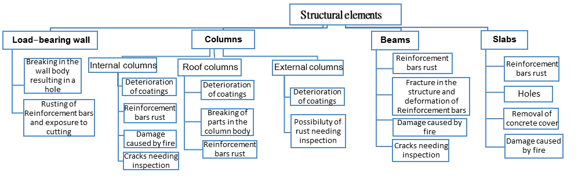Through the inspection, we identified several damages in the structural elements, which we will classify as follows, along with diagnosing each case individually and proposing appropriate restoration solutions.

**Structural Assessment and Load-Bearing Capacity of the Building:**

Despite the agricultural bank building suffering multiple damages during the war, the general appearance of the façade remains relatively intact. The damages are primarily limited to the collapse of the external cladding of the façades, along with some damage to the windows and doors.

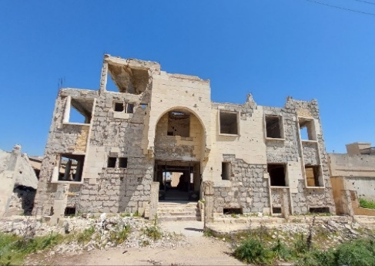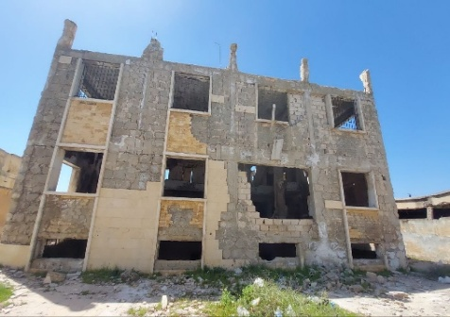As for the external fence of the building, it is in a state of complete collapse.

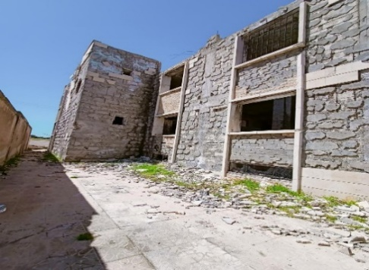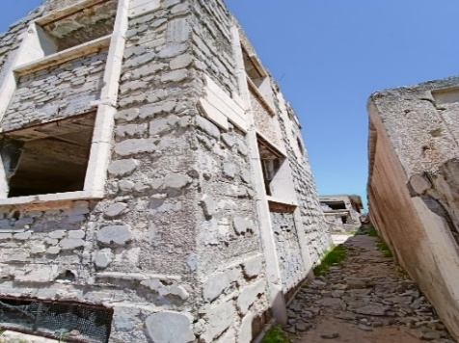

West elevation

East elevation

South elevation

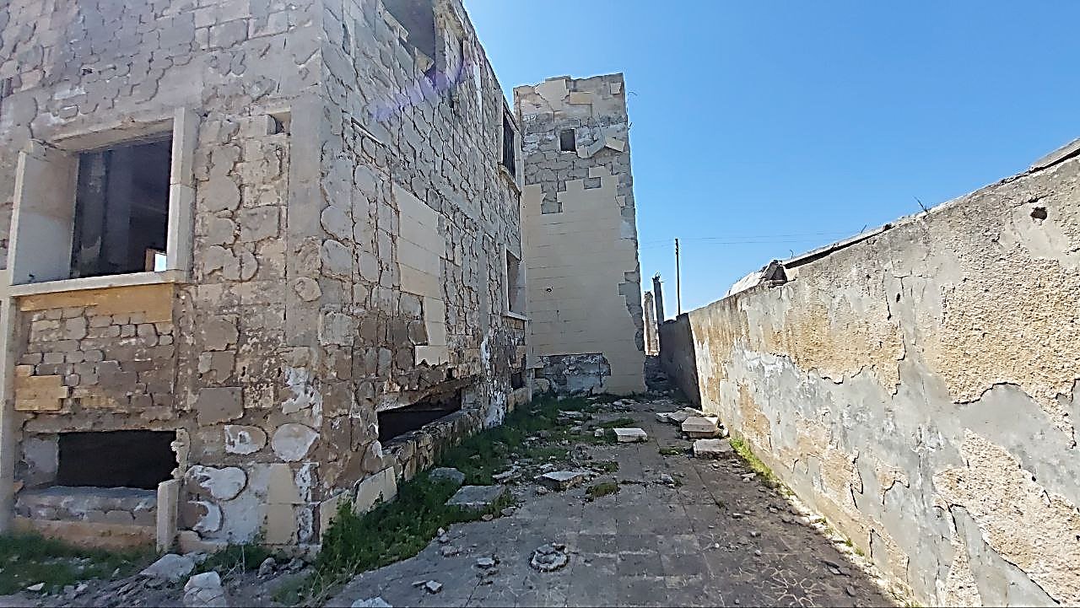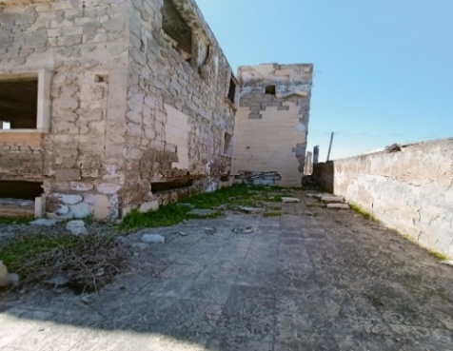

North elevation

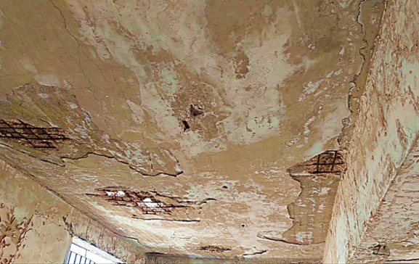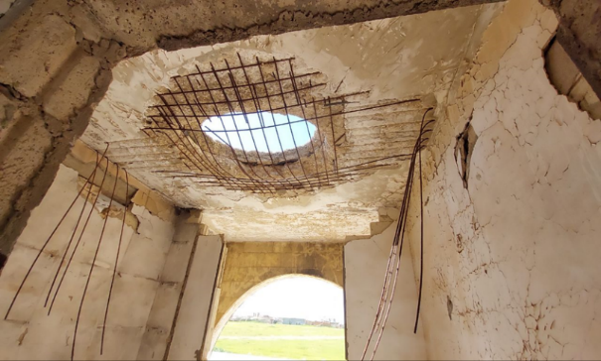**slabs Assessment :**

The First-Floor Slab Damage Assessment and Proposed Restoration Methods

The first-floor slab sustained multiple direct impacts, resulting in openings of varying dimensions: some exceeding one meter and others smaller.

Figure (2-2): The reinforcement steel bars show signs of cutting and bending.

Figures (2-2 and 2-3): The concrete cover of the reinforcement has been removed, leaving the steel exposed to weather conditions, leading to significant rust accumulation and section loss in the steel reinforcement.

**Proposed Restoration Methods:**

Method 1: Strengthening by Casting a New Overlay Slab Over the Existing Slab

This method is beneficial for strengthening the roof slab or slabs prior to finishing works, as it minimizes the floor height, potentially affecting door heights and dimensions allocated for kitchens and bathrooms per engineering standards.

Steps:

1 Temporarily support the affected slabs using wooden props or jacks to relieve the load.

2. Cut the damaged steel reinforcement, clean the remaining reinforcement, and coat it with anti-corrosion epoxy.

3. Roughen the slab surface, drill holes, and embed metal anchors into the upper slab surface using epoxy at intervals of 30–40 cm in all directions.

4. Clean and apply a rich cement slurry.

5. Install two layers of longitudinal and transverse reinforcement bars.

6. Pour concrete with suitable specifications, adhering to the required dimensions and thicknesses.

**Method 2: Localized Strengthening of the Slab at the Openings**

Steps:

1. Temporarily support the affected slabs using wooden props or jacks to relieve the load.

2. Remove the damaged steel reinforcement, clean the existing steel, and add new steel bars of the same diameter. Ensure proper bonding between the old and new bars by overlapping or welding (100 mm for the existing steel).

3 .Coat the steel bars with anti-corrosion epoxy.

4. Apply a medium-viscosity epoxy bonding agent to the old concrete surface to ensure adhesion between the old and new concrete.

5. Construct a wooden formwork by drilling into the slab, followed by pouring grout or similar material. Grout is preferred due to its negligible shrinkage compared to cement mortar, preventing joint failure between the old slab and the poured section. Its excellent bonding and friction properties ensure efficient composite action

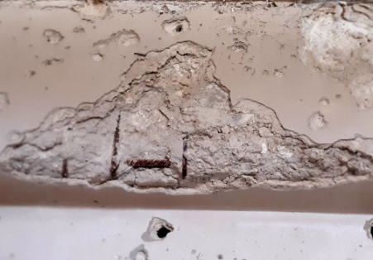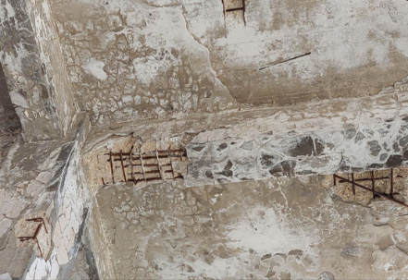**Beam Assessment and Proposed Restoration Methods Assessment**

The images reveal that the beams have been subjected to shear and bending forces, resulting in varying degrees of damage across the building's beams. This includes the loss of finishing layers, partial loss of beam concrete, exposure, and corrosion of reinforcement steel.

Proposed Restoration Methods

Case 1: Corrosion of Reinforcement Steel Below 20%

Note: The corrosion percentage must be determined using specialized tests and equipment.

1. Temporarily support the beams to relieve the load.

2. Remove the concrete cover.

3. Clean the corroded reinforcement steel using a wire brush or sandblasting, then coat the steel with an anti-corrosion material.

4. Apply a medium-viscosity epoxy bonding agent to the old concrete surface for bonding with new concrete. Before it dries, spray the surfaces with a cement slurry and replace the concrete cover with special concrete made of:

-Fine aggregate with a maximum particle size of 5 mm.

-Sand and cement in high ratios, not less than 400 kg/m³.

-Additives to improve fluidity, not less than 6 kg/m³ of concrete.

**Note**: In some cases, the concrete cover can be made from polymer-modified cement mortar, fiberglass-reinforced mortar, or epoxy mortar, depending on the structural requirements.

Case 2: Corrosion of Reinforcement Steel Above 20%

1. Temporarily support the beams to relieve the load.

2. Remove the concrete cover.

3. Clean the corroded reinforcement steel using a wire brush or sandblasting, then coat the steel with an anti-corrosion material.

4. Install new ties by embedding 8 mm-diameter dowels at 25–50 cm intervals. Drill holes into the beam surface with a depth of 5–7 times the dowel diameter, then secure them using high-viscosity epoxy. Afterward, install the new ties and primary reinforcement steel.

5. Apply a medium-viscosity epoxy bonding agent to the old concrete surface for bonding with new concrete. Before it dries, spray the surfaces with a cement slurry and replace the concrete cover with special concrete made of:

-Fine aggregate with a maximum particle size of 5 mm.

-Sand and cement in high ratios, not less than 400 kg/m³.

-Additives to improve fluidity, not less than 6 kg/m³ of concrete.

**Beam Assessment and Proposed Restoration Methods**

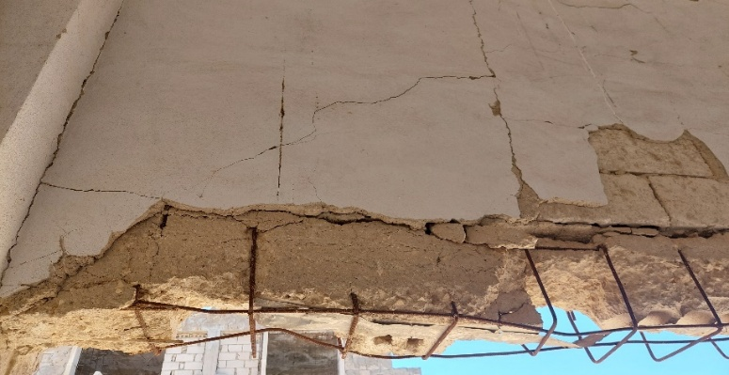

The beams exhibit fractures in their body and deformation in the reinforcement steel, likely caused by pressure from an explosion.

**Proposed Restoration Methods**

Method 1: Strengthening Beams with Concrete Jacketing in the Presence of Steel Corrosion

Step 1: Addressing Steel Corrosion

Temporarily support the beam to relieve the load.

Thoroughly clean the corroded steel reinforcement and coat it with anti-corrosion material.

Install new ties and main reinforcement steel as required. Replace severely damaged steel with new reinforcement before casting the concrete jacket.

Step 2: Casting the Concrete Jacket

1. Apply a medium-viscosity epoxy adhesive to the old concrete surface to ensure bonding with the new concrete.

2. Cast the concrete jacket before the epoxy dries. This can be done via:

Shotcrete: Sprayed concrete application.

Formwork: Construct wooden formwork with openings on the sides or through ceiling holes for pouring.

3. The concrete used should meet the following specifications:

-Composed of clean river sand and aggregate.

-Contains additives to reduce shrinkage.

-Maximum aggregate size: 25 mm.

-Cement content: 400 kg/m³.

After strengthening the beams using these methods, the beams should be tested for structural resistance. If weakness persists, further strengthening might be necessary, depending on the building’s importance and budget. Two additional strengthening methods are:

Method1: Strengthening Beams with Steel Plates (Steel Jacketing)

1. Roughen and clean the concrete surface where steel plates will be installed.

2. Drill holes in both the steel plates and the concrete surface.

3. Apply a 5 mm layer of epoxy mortar to the steel plates.

4. Secure the steel plates to the concrete surface using Fischer nails.

5. Before attaching the steel plates, coat the concrete surface with a bonding epoxy adhesive.

Method 2: Strengthening Beams with Carbon Fiber

1. Clean and level the surface.

2. Apply a medium-viscosity epoxy adhesive to the surface.

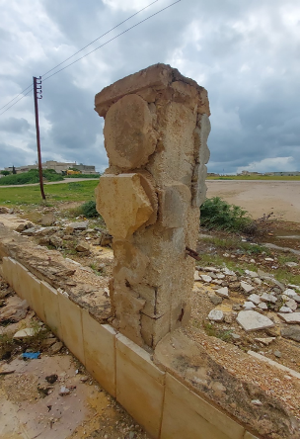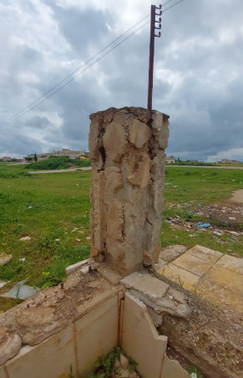3. Bond the carbon fiber sheets to the concrete surface.

**Assessment of Fence Columns**:

Proposed Restoration Methods:

Due to the removal of the finishing layers and the exposure of the concrete body, it is expected that the reinforcement steel has corroded in some areas, with a corrosion percentage likely below 20% (tests and necessary inspections are required to confirm this). Because these columns are located outdoors and exposed to various weather conditions, the following restoration steps are suggested:

1. No need for temporary support, as the columns do not bear any loads.

2. Remove the concrete cover.

3. Clean the rust on the reinforcement steel using a wire brush or sandblasting, then coat the reinforcement steel with an anti-corrosion material.

4. Apply a medium-viscosity epoxy adhesive to the old concrete surface to bond it with the new concrete. Before the epoxy dries, spray the surfaces with a cement slurry, then replace the concrete cover with specially formulated concrete consisting of:

-Fine aggregate with a maximum particle size of 5 mm.

-High-ratio sand and cement, with cement content not less than 400 kg/m³.

-Additives to enhance fluidity, not less than 6 kg/m³ of concrete

**Note:**

In certain cases, the concrete cover can be replaced using polymer-modified cement mortar, fiberglass-reinforced cement mortar, or epoxy mortar, depending on the structural requirements.

**Assessment of Roof Columns:**

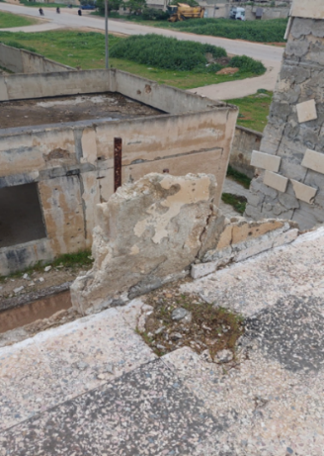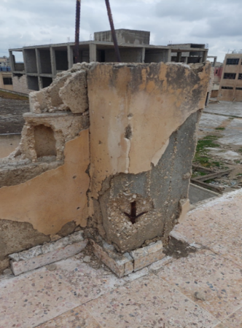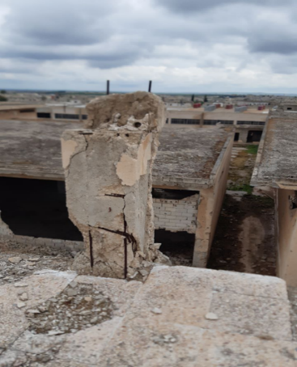

Significant damage is observed in the roof columns due to their location in the building’s direct impact zone. The following issues are noted:

Multiple fractures in the columns.

Alteration of the cross-sections of some columns.

Exposure and corrosion of the reinforcement steel due to direct exposure to various weather conditions.

**Proposed Restoration Methods:**

First: Testing for Corrosion Percentage

Two scenarios should be identified based on the corrosion percentage:

Case 1: Corrosion Percentage Less Than 20%

1 Temporary Column Support:Provide temporary support to relieve loads from the columns. However, in this case, there is no need for temporary support as the columns do not bear any loads.

2. Removal of the Concrete Cover.

3. Cleaning Corroded Reinforcement Steel:Clean the rust using a wire brush or sandblasting, then coat the steel with an anti-corrosion material.

4. Coating Old Concrete:Apply a medium-viscosity epoxy adhesive to the old concrete to bond it with the new concrete. Before the epoxy dries, spray the surface with a cement slurry and replace the concrete cover using special concrete composed of:

-Fine aggregate with a maximum particle size of 5 mm.

-Sand and cement with high ratios, with a cement content of no less than 400 kg/m³.

-Additives to increase fluidity, at a rate of no less than 6 kg/m³ of concrete.

**Note:**

In some cases, the concrete cover can be made from polymer-modified cement mortar, fiberglass-reinforced cement mortar, epoxy mortar, or Sika Grout, depending on structural requirements.

Case 2: Corrosion Percentage Greater Than 20%

1. Temporary Column Support:As mentioned earlier, no temporary support is needed in this case.

2. Removal of the Concrete Cover.

3. Cleaning Corroded Reinforcement Steel:Use a wire brush or sandblasting to clean the rust, then coat the steel with an anti-corrosion material.

4. Adding Steel Dowels:

Insert dowels with an 8 mm diameter, spaced 25–50 cm apart, to connect the new ties. Drill holes into the column surface at a depth of 5–7 times the dowel diameter. Secure the dowels using high-viscosity epoxy, install the new ties, and then add the new main reinforcement steel.

5. Coating Old Concrete:

Apply a medium-viscosity epoxy adhesive to bond the old and new concrete. Before the epoxy dries, spray the surface with a cement slurry, then replace the concrete cover using special concrete composed of:

-Fine aggregate with a maximum particle size of 5 mm.

-Sand and cement with high ratios, with a cement content of no less than 400 kg/m³.

-Additives to increase fluidity, at a rate of no less than 6 kg/m³ of concrete.

**Note:**

If columns with such damage are located within floors, they must be strengthened with concrete jackets, steel jackets, or carbon fiber. However, since these columns are located on the roof and do not bear any loads, strengthening them using these methods is unnecessary and would result in material wastage.

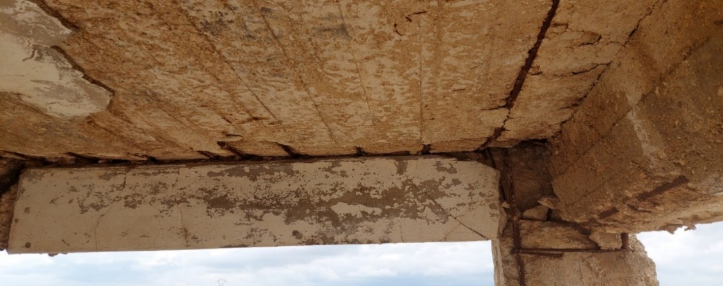

This figure illustrates the damage to the load-bearing columns of a slab adjacent to the stairwell, which is also located in the area of direct impact. The damage includes separation at the junction between the columns and the beams, resulting in deformation of the reinforcement steel and minor cracking in the concrete body due to failure to withstand the applied compressive forces.

Proposed Strengthening Method:

1. Temporary Support: Provide temporary support for the area surrounding the damaged column using scaffolding or steel props. Then, address the sagging in the beam caused by the column damage by employing a hydraulic jack.

2. Concrete Removal: Remove the concrete from the column and the lower part of the beam to ensure proper connection between the new column reinforcement and the beam reinforcement.

3. Reinforcement Replacement: Remove the damaged reinforcement steel and replace it with new steel, ensuring proper anchorage of the new reinforcement with the undamaged column reinforcement and with the beam reinforcement.

4. Formwork and Concrete Pouring: Install formwork and pour the concrete, consisting of gravel, sand, 400 kg/m³ of cement, and shrinkage-reducing additives.

The column is poured either through holes in the upper part of the beam or in stages to ensure proper compaction and bonding.

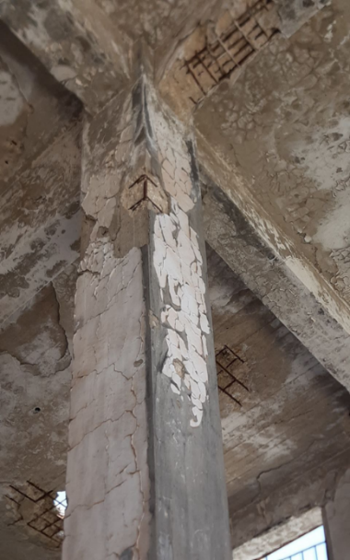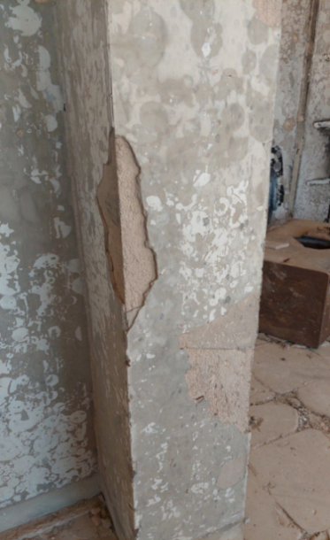**Assessment of Internal Columns:**

Figure 1

Figure 2

In Figure 1, we observe the cracking of a portion of the column cladding, while in Figure 2, there is rust and oxidation of the steel reinforcement along with concrete cover degradation in some columns within the building. This condition results in a reduction in the original reinforcement area relative to the column's cross-sectional area.

Typically, this condition occurs in columns that are somewhat distant from the explosion zones.

**Proposed Repair Solutions:**

1. For the first column: There are no structural damages to the column body; therefore, the repair process will be limited to simple maintenance to restore the column to its original condition (using cement mortar and paint).

2. For the second column: The repair will involve treating the rust, replacing the lost concrete parts of the column, as previously outlined.

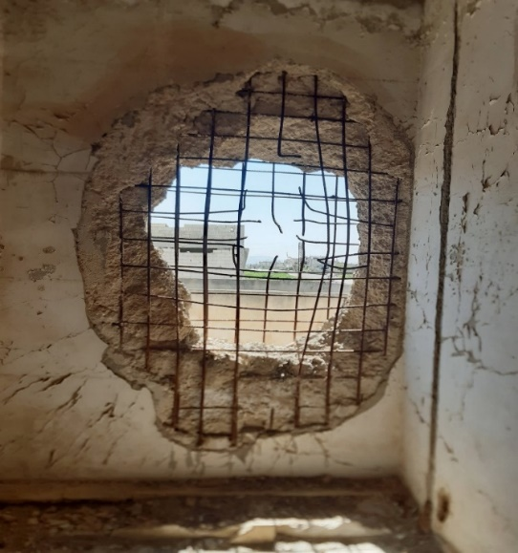**Evaluation of Load-Bearing Walls:**

We observe a crack in the body of the load-bearing wall inside the building caused by a direct shell impact.

Proposed Repair Solutions:

1. Temporary Support: Provide temporary support for the area surrounding the damaged wall to remove the loads from it.

2. Concrete Removal: Remove all the concrete from the wall.

3. Reinforcement Replacement: Remove the bent reinforcement by cutting out the deformed section and replacing it with new reinforcement.

4. Formwork and Concrete Pouring: Install the wooden formwork according to the dimensions of the new walls. The concrete can be poured either in stages or by creating holes in the ceiling, then pouring the concrete. The concrete mix consists of gravel, 400 kg/m³ of cement, sand, and shr

**Block Walls Evaluation:**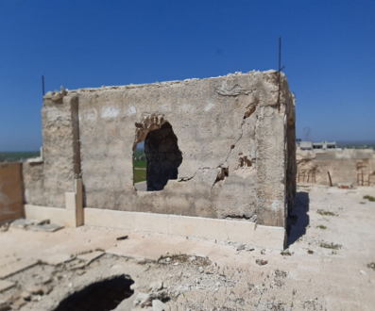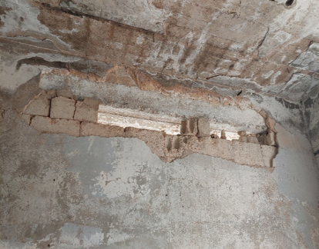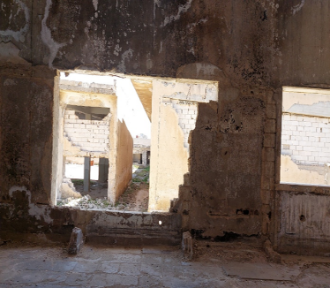

We observe the collapse and falling of parts of the block walls inside the building, along with the loss of cladding. Block walls are considered weak elements that cannot withstand the pressure from explosions. However, they play a significant role in reducing the shock impact of the explosion on the elements located behind them.

Proposed Repair Solutions:

1. Identify the Damage Location

2 Replace the Damaged Block Units: Replace the damaged blocks with new ones, using an appropriate mortar mix.

3. Ensure Continuous Tiling

Continuous tiling is necessary to reduce shrinkage.

**Cases Exposed to Fire:**

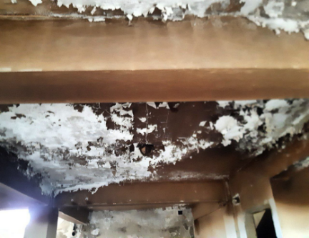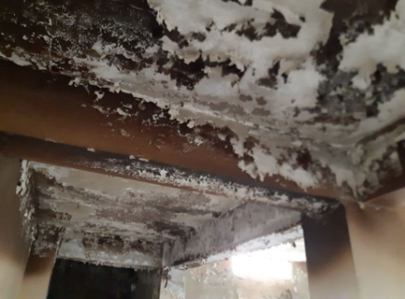

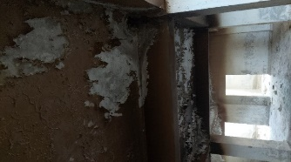

The basement slab and some of the beams within it were exposed to fire, causing damage to the elements, as shown in the previous figure.

We can distinguish between high-temperature fires and ordinary fires. The black color on the elements indicates exposure to a mild fire and smoke resulting from incomplete combustion of some materials in the building, while the white color indicates exposure to a severe fire and high temperature. The damage to structural elements increases as the white color intensifies.

From the images, we observe the presence of mild fire damage caused by an explosion effect, with the dark black color indicating soot or smoke from the fire. The white color is due to the peeling of paint layers and moisture.

Proposed Repair Solutions:

1. Thoroughly Clean the Burnt Surfaces

2.Use Appropriate Epoxy Paints

3. Cover with Special Types of Cement Mortar

4. Reapply Paint and Necessary Cladding Layers

Solutions for Other Cases, If Present:

First: If the reinforcement bars (rebar) are exposed and rusted, the rust should be removed, and the bars should be cleaned of harmful residues. They should then be coated with an appropriate rust-resistant paint in the areas being repaired.

Second: If the fire has continued until it caused the steel to soften (flow), the solution is either to reinforce the slab or remove it if the damage has progressed.

**Crack Cases:**

There were various crack cases in the building across different elements, both structural and non-structural. We believe that most of these cracks are due to explosion pressure, and it is not possible to explain cracks caused by these reasons as they cannot be predicted. Each case must be studied individually.

The following images show the different cases:

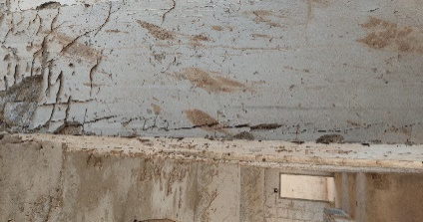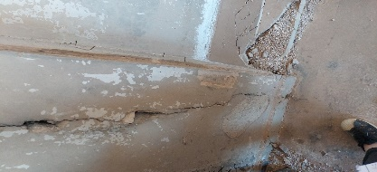

First: Here, we notice the presence of cracks in the columns

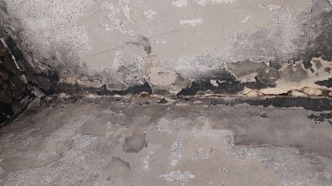

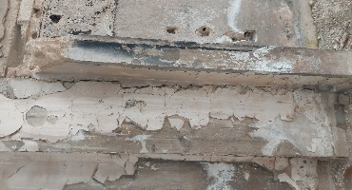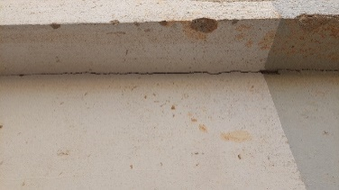In Image 1, we observe a separation crack between the block walls.

In Images 2 and 3, we notice a separation crack between the block wall and the column.

1

2

3

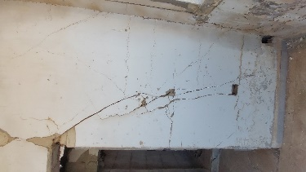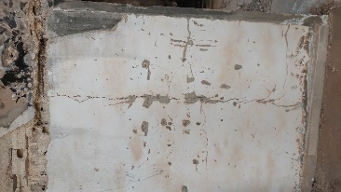

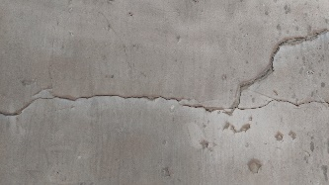

Cracks are observed in the block walls.

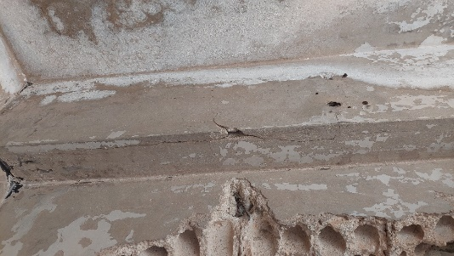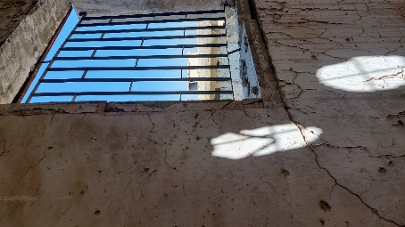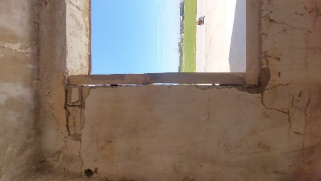

A crack in the beam.

We notice the presence of cracks around the window perimeter

**Staircase Condition:**

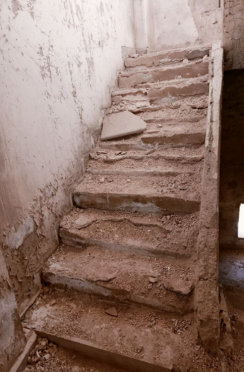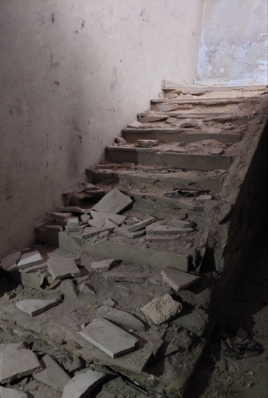The following figure shows the damage to the staircase in the studied building:

We observe complete breakage of the staircase cladding, which poses a slipping hazard due to the instability of the steps underfoot. It is important to note the need to thoroughly examine the structural system, as it is difficult to assess through visual inspection, and then the appropriate solution can be proposed.

As for the current situation, we suggest the following solution:

1. Remove the broken parts and clean thoroughly.

2. Inspect the structural system, and if its integrity is confirmed, perform simple repairs to the staircase by using cementitious mortar for the damaged sections.

3.Reapply the staircase cladding

**Building Floors:**

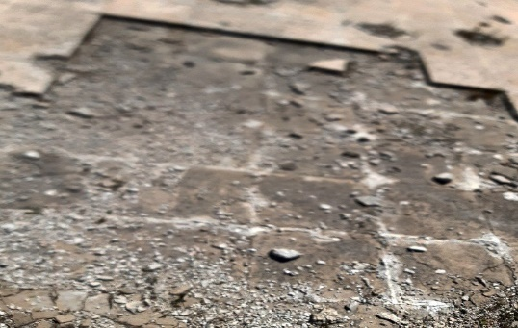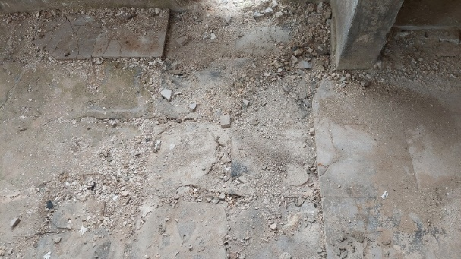We observe the removal of the floor coverings.

**Damage to Installations:**

As shown in the following image, we observe damage to the installations inside the building, causing them to become completely non-functional.

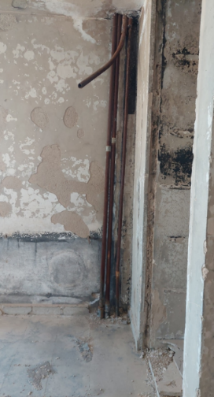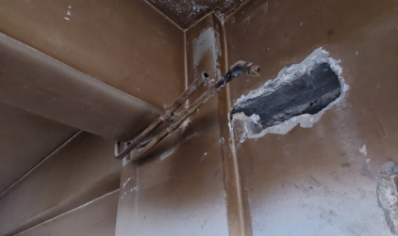

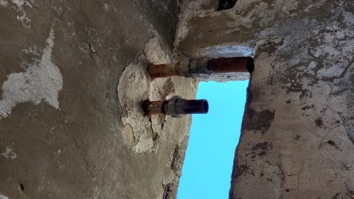

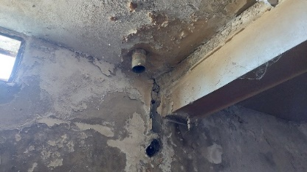

**Note:**

We did not address the foundations as the war damage sustained by the studied case affected only the exposed elements above the ground surface.